SET echo on;

SET serveroutput on;

/* Drop tables, sequence, and other objects you create*/

DROP TABLE OrderDetails;

DROP TABLE Item;

DROP TABLE CustomerOrder;

DROP TABLE ItemType;

DROP TABLE Customer;

DROP SEQUENCE Customer_Seq;

DROP SEQUENCE CustomerOrder_Seq;

DROP SEQUENCE OrderDetails_Seq;

DROP SEQUENCE Item_Seq;

DROP SEQUENCE ItemType_Seq;

/* Create 5 tables */

CREATE TABLE Customer

(

Customer_ID NUMBER NOT NULL,

Cust_FName VARCHAR2 (50),

Cust_LName VARCHAR2 (50),

Cust_Address VARCHAR2 (100),

Cust_ZipCode VARCHAR2(10),

Cust_PhoneNum VARCHAR2(15),

Cust_Email VARCHAR2(50),

CONSTRAINT pk_customer PRIMARY KEY (Customer_ID)

);

COMMENT ON TABLE Customer IS 'Table used to store Customer information';

DESCRIBE Customer;

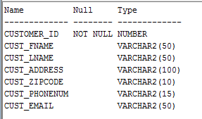

CREATE TABLE CustomerOrder

(

Customer_Order_ID NUMBER NOT NULL,

Order_Date DATE,

Customer_ID NUMBER NOT NULL,

CONSTRAINT pk_CustomerOrder PRIMARY KEY (Customer_Order_Id),

CONSTRAINT fk_Customer FOREIGN KEY (Customer_ID)

REFERENCES Customer

);

COMMENT ON TABLE CustomerOrder IS

'Table used to store main order information for each customer';

DESCRIBE CustomerOrder;

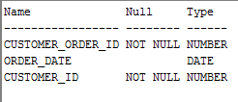

CREATE TABLE ItemType

(

Item_Type_ID NUMBER NOT NULL,

Type_Name VARCHAR2(50),

CONSTRAINT pk_ItemType PRIMARY KEY (Item_Type_ID)

);

COMMENT ON TABLE ItemType IS

'Table serves as a lookup or reference for the type of item an item is';

DESCRIBE ItemType;

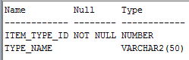

CREATE TABLE Item

(

Item_ID NUMBER NOT NULL,

Item_ListPrice NUMBER,

Item_Cost NUMBER,

Item_Name VARCHAR2 (50),

Item_Type_ID NUMBER,

Spec_Documents BLOB,

Total_Qty NUMBER,

Reorder_Qty NUMBER,

Date_Added DATE,

CONSTRAINT pk_Item PRIMARY KEY (Item_ID),

CONSTRAINT fk_ItemType FOREIGN KEY (Item_Type_ID)

REFERENCES ItemType

);

COMMENT ON TABLE Item IS

'Used to list all the necessary properties belonging to each specific item';

DESCRIBE Item;

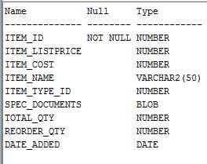

CREATE TABLE OrderDetails

(

Order_Details_ID NUMBER NOT NULL,

Order_Details_Qty NUMBER,

Discount NUMBER,

Item_ID NUMBER NOT NULL,

Customer_Order_ID NUMBER NOT NULL,

CONSTRAINT pk_OrderDetails PRIMARY KEY (Order_Details_ID),

CONSTRAINT fk_CustomerOrder FOREIGN KEY (Customer_Order_ID)

REFERENCES CustomerOrder,

CONSTRAINT fk_OrderItem FOREIGN KEY (Item_ID)

REFERENCES Item

);

COMMENT ON TABLE OrderDetails IS

'Contains the breakdown of each item ordered from CustomerOrder Table';

DESCRIBE OrderDetails;

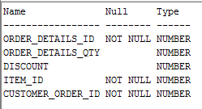

/* Create indexes on foreign keys*/

CREATE INDEX fk_Customer on CustomerOrder(Customer_ID);

CREATE INDEX fk_ItemType on Item(Item_Type_ID);

CREATE INDEX fk_CustomerOrder on OrderDetails(Customer_Order_ID);

CREATE INDEX fk_OrderItem on OrderDetails(Item_ID);

/* Create sequence*/

CREATE SEQUENCE Customer_Seq

START WITH 1

INCREMENT BY 1;

CREATE SEQUENCE CustomerOrder_Seq

START WITH 1

INCREMENT BY 1;

CREATE SEQUENCE OrderDetails_Seq

START WITH 1

INCREMENT BY 1;

CREATE SEQUENCE Item_Seq

START WITH 1

INCREMENT BY 1;

CREATE SEQUENCE ItemType_Seq

START WITH 1

INCREMENT BY 1;

/* Data Dictionary query */

PURGE recyclebin;

/*The next query returns a list of all objects in the user_objects table*/

SELECT /*fixed*/ object_name, object_type FROM user_objects ORDER BY object_type;

/* Insert data into each table */

INSERT INTO Customer (Customer_ID, Cust_FName, Cust_LName, Cust_Address, Cust_ZipCode, Cust_PhoneNum, Cust_Email)

VALUES (Customer_Seq.NEXTVAL, 'Bob', 'Roberts', '123 ABC Street','31088', '123-456-0000', 'BobRoberts@gmail.com');

INSERT INTO Customer (Customer_ID, Cust_FName, Cust_LName, Cust_Address, Cust_ZipCode, Cust_PhoneNum, Cust_Email)

VALUES (Customer_Seq.NEXTVAL, 'Mary', 'Jane', '45 Alberta Lane ','31771', '476-897-1111', 'MaryJane@gmail.com');

INSERT INTO Customer (Customer_ID, Cust_FName, Cust_LName, Cust_Address, Cust_ZipCode, Cust_PhoneNum, Cust_Email)

VALUES (Customer_Seq.NEXTVAL, 'Brandon', 'Russell', '123 Finegand Place ','31771', '234-123-222', 'HighFive34@gmail.com');

INSERT INTO Customer (Customer_ID, Cust_FName, Cust_LName, Cust_Address, Cust_ZipCode, Cust_PhoneNum, Cust_Email)

VALUES (Customer_Seq.NEXTVAL, 'James', 'Doe', '46 Alberta Lane ','31771', '476-897-1112', 'JamesDoe@gmail.com');

INSERT INTO Customer (Customer_ID, Cust_FName, Cust_LName, Cust_Address, Cust_ZipCode, Cust_PhoneNum, Cust_Email)

VALUES (Customer_Seq.NEXTVAL, 'Jim', 'Bob', '47 Alberta Lane ','31771', '476-897-1113', 'JimBob@gmail.com');

INSERT INTO Customer (Customer_ID, Cust_FName, Cust_LName, Cust_Address, Cust_ZipCode, Cust_PhoneNum, Cust_Email)

VALUES (Customer_Seq.NEXTVAL, 'Patricia', 'Russell', '48 Alberta Lane ','31771', '476-897-1114', 'PRussell@gmail.com');

INSERT INTO Customer (Customer_ID, Cust_FName, Cust_LName, Cust_Address, Cust_ZipCode, Cust_PhoneNum, Cust_Email)

VALUES (Customer_Seq.NEXTVAL, 'Jane', 'Johnson', '49 Alberta Lane ','31771', '476-897-1115', 'JJ123@gmail.com');

INSERT INTO Customer (Customer_ID, Cust_FName, Cust_LName, Cust_Address, Cust_ZipCode, Cust_PhoneNum, Cust_Email)

VALUES (Customer_Seq.NEXTVAL, 'Hyon', 'Yi', '50 Alberta Lane ','31771', '476-897-1116', 'HyonYi@gmail.com');

INSERT INTO Customer (Customer_ID, Cust_FName, Cust_LName, Cust_Address, Cust_ZipCode, Cust_PhoneNum, Cust_Email)

VALUES (Customer_Seq.NEXTVAL, 'Keith', 'Jordan', '51 Alberta Lane ','31771', '476-897-1117', 'KJ88@gmail.com');

INSERT INTO Customer (Customer_ID, Cust_FName, Cust_LName, Cust_Address, Cust_ZipCode, Cust_PhoneNum, Cust_Email)

VALUES (Customer_Seq.NEXTVAL, 'Pete', 'Smith', '52 Alberta Lane ','31771', '476-897-1118', 'PeteS33@gmail.com');

INSERT INTO CustomerOrder (Customer_Order_ID, Customer_ID, Order_Date)

VALUES (CustomerOrder_Seq.NEXTVAL, 1, '12-FEB-16');

INSERT INTO CustomerOrder (Customer_Order_ID, Customer_ID, Order_Date)

VALUES (CustomerOrder_Seq.NEXTVAL, 2, '15-FEB-16');

INSERT INTO CustomerOrder (Customer_Order_ID, Customer_ID, Order_Date)

VALUES (CustomerOrder_Seq.NEXTVAL, 3, '16-FEB-16');

INSERT INTO CustomerOrder (Customer_Order_ID, Customer_ID, Order_Date)

VALUES (CustomerOrder_Seq.NEXTVAL, 4, '15-JAN-16');

INSERT INTO CustomerOrder (Customer_Order_ID, Customer_ID, Order_Date)

VALUES (CustomerOrder_Seq.NEXTVAL, 5, '10-JAN-16');

INSERT INTO CustomerOrder (Customer_Order_ID, Customer_ID, Order_Date)

VALUES (CustomerOrder_Seq.NEXTVAL, 6, '01-FEB-16');

INSERT INTO CustomerOrder (Customer_Order_ID, Customer_ID, Order_Date)

VALUES (CustomerOrder_Seq.NEXTVAL, 7, '03-DEC-15');

INSERT INTO CustomerOrder (Customer_Order_ID, Customer_ID, Order_Date)

VALUES (CustomerOrder_Seq.NEXTVAL, 8, '20-NOV-15');

INSERT INTO CustomerOrder (Customer_Order_ID, Customer_ID, Order_Date)

VALUES (CustomerOrder_Seq.NEXTVAL, 9, '22-OCT-15');

INSERT INTO CustomerOrder (Customer_Order_ID, Customer_ID, Order_Date)

VALUES (CustomerOrder_Seq.NEXTVAL, 10, '23-FEB-16');

INSERT INTO ItemType (Item_Type_ID, Type_Name)

VALUES (ItemType_Seq.NEXTVAL, 'CPU');

INSERT INTO ItemType (Item_Type_ID, Type_Name)

VALUES (ItemType_Seq.NEXTVAL, 'Battery');

INSERT INTO ItemType (Item_Type_ID, Type_Name)

VALUES (ItemType_Seq.NEXTVAL, 'Desktop');

INSERT INTO ItemType (Item_Type_ID, Type_Name)

VALUES (ItemType_Seq.NEXTVAL, 'Laptop');

INSERT INTO ItemType (Item_Type_ID, Type_Name)

VALUES (ItemType_Seq.NEXTVAL, 'Monitor');

INSERT INTO ItemType (Item_Type_ID, Type_Name)

VALUES (ItemType_Seq.NEXTVAL, 'Printer');

INSERT INTO ItemType (Item_Type_ID, Type_Name)

VALUES (ItemType_Seq.NEXTVAL, 'RAM');

INSERT INTO ItemType (Item_Type_ID, Type_Name)

VALUES (ItemType_Seq.NEXTVAL, 'Floppy Drive');

INSERT INTO ItemType (Item_Type_ID, Type_Name)

VALUES (ItemType_Seq.NEXTVAL, 'DVD Drive');

INSERT INTO ItemType (Item_Type_ID, Type_Name)

VALUES (ItemType_Seq.NEXTVAL, 'Video Card');

INSERT INTO Item (Item_ID, Item_ListPrice, Item_Cost, Item_Name, Item_Type_ID, Spec_Documents, Total_Qty, Reorder_Qty, Date_Added)

VALUES (Item_Seq.NEXTVAL, 123.23, 50.12, '4.2GHZ Intel I5 6th Gen',1, EMPTY_BLOB(), 100, 1, '01-FEB-16');

INSERT INTO Item (Item_ID, Item_ListPrice, Item_Cost, Item_Name, Item_Type_ID, Spec_Documents, Total_Qty, Reorder_Qty, Date_Added)

VALUES (Item_Seq.NEXTVAL, 1000.01, 500.08, 'Dell XPS 13 Laptop', 4, EMPTY_BLOB(), 100, 1, '01-JAN-16');

INSERT INTO Item (Item_ID, Item_ListPrice, Item_Cost, Item_Name, Item_Type_ID, Spec_Documents, Total_Qty, Reorder_Qty, Date_Added)

VALUES (Item_Seq.NEXTVAL, 56.34, 12.12, 'A42-U53 Battery', 2, EMPTY_BLOB(), 100, 10, '01-FEB-15');

INSERT INTO Item (Item_ID, Item_ListPrice, Item_Cost, Item_Name, Item_Type_ID, Spec_Documents, Total_Qty, Reorder_Qty, Date_Added)

VALUES (Item_Seq.NEXTVAL, 450.25, 80.00, 'HP Pavilion Desktop', 3, EMPTY_BLOB(), 50, 2, '01-APR-15');

INSERT INTO Item (Item_ID, Item_ListPrice, Item_Cost, Item_Name, Item_Type_ID, Spec_Documents, Total_Qty, Reorder_Qty, Date_Added)

VALUES (Item_Seq.NEXTVAL, 100.25, 68.00, 'HP 22 Inch Monitor', 5, EMPTY_BLOB(), 50, 6, '01-JUN-15');

INSERT INTO Item (Item_ID, Item_ListPrice, Item_Cost, Item_Name, Item_Type_ID, Spec_Documents, Total_Qty, Reorder_Qty, Date_Added)

VALUES (Item_Seq.NEXTVAL, 75.25, 25.00, 'LexMark Printer 5500', 6, EMPTY_BLOB(), 25, 2, '01-JAN-15');

INSERT INTO Item (Item_ID, Item_ListPrice, Item_Cost, Item_Name, Item_Type_ID, Spec_Documents, Total_Qty, Reorder_Qty, Date_Added)

VALUES (Item_Seq.NEXTVAL, 40.00, 10.00, '4GB DDR3 144-Pin RAM', 7, EMPTY_BLOB(), 25, 5, '01-JUL-15');

INSERT INTO Item (Item_ID, Item_ListPrice, Item_Cost, Item_Name, Item_Type_ID, Spec_Documents, Total_Qty, Reorder_Qty, Date_Added)

VALUES (Item_Seq.NEXTVAL, 15.25, 3.00, 'Dell 3.5 Inch Floppy', 8, EMPTY_BLOB(), 10, 3, '01-SEP-15');

INSERT INTO Item (Item_ID, Item_ListPrice, Item_Cost, Item_Name, Item_Type_ID, Spec_Documents, Total_Qty, Reorder_Qty, Date_Added)

VALUES (Item_Seq.NEXTVAL, 55.25, 28.00, 'Dell 200x DVD Burner', 9, EMPTY_BLOB(), 10, 2, '01-MAR-15');

INSERT INTO Item (Item_ID, Item_ListPrice, Item_Cost, Item_Name, Item_Type_ID, Spec_Documents, Total_Qty, Reorder_Qty, Date_Added)

VALUES (Item_Seq.NEXTVAL, 300.00, 58.00, 'AMD EVGA 1GB DDR3 Video Card', 10, EMPTY_BLOB(), 10, 1, '01-JUN-15');

INSERT INTO OrderDetails (Order_Details_ID, Order_Details_Qty, Item_ID, Customer_Order_ID, Discount)

VALUES (OrderDetails_Seq.NEXTVAL, 1, 1, 1, .05);

INSERT INTO OrderDetails (Order_Details_ID, Order_Details_Qty, Item_ID, Customer_Order_ID, Discount)

VALUES (OrderDetails_Seq.NEXTVAL, 2, 2, 1, .05);

INSERT INTO OrderDetails (Order_Details_ID, Order_Details_Qty, Item_ID, Customer_Order_ID, Discount)

VALUES (OrderDetails_Seq.NEXTVAL, 3, 3, 2, 0);

INSERT INTO OrderDetails (Order_Details_ID, Order_Details_Qty, Item_ID, Customer_Order_ID, Discount)

VALUES (OrderDetails_Seq.NEXTVAL, 4, 4, 3, .10);

INSERT INTO OrderDetails (Order_Details_ID, Order_Details_Qty, Item_ID, Customer_Order_ID, Discount)

VALUES (OrderDetails_Seq.NEXTVAL, 5, 5, 4, 0);

INSERT INTO OrderDetails (Order_Details_ID, Order_Details_Qty, Item_ID, Customer_Order_ID, Discount)

VALUES (OrderDetails_Seq.NEXTVAL, 6, 6, 5, 0);

INSERT INTO OrderDetails (Order_Details_ID, Order_Details_Qty, Item_ID, Customer_Order_ID, Discount)

VALUES (OrderDetails_Seq.NEXTVAL, 7, 7, 6, 0);

INSERT INTO OrderDetails (Order_Details_ID, Order_Details_Qty, Item_ID, Customer_Order_ID, Discount)

VALUES (OrderDetails_Seq.NEXTVAL, 8, 8, 7, 0);

INSERT INTO OrderDetails (Order_Details_ID, Order_Details_Qty, Item_ID, Customer_Order_ID, Discount)

VALUES (OrderDetails_Seq.NEXTVAL, 1, 9, 8, 0);

INSERT INTO OrderDetails (Order_Details_ID, Order_Details_Qty, Item_ID, Customer_Order_ID, Discount)

VALUES (OrderDetails_Seq.NEXTVAL, 1, 10, 9, 0);

commit;

/* Verify each tables content */

SELECT /*fixed*/ * FROM Customer;

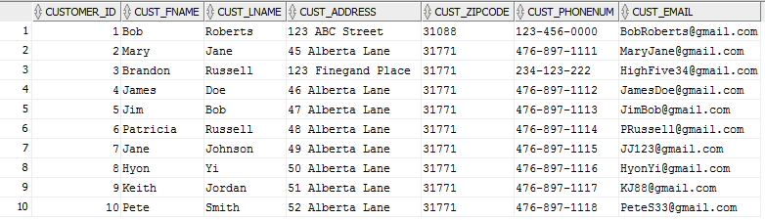

SELECT /*fixed*/ * FROM CustomerOrder;

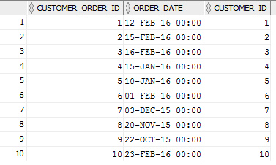

SELECT /*fixed*/ * FROM OrderDetails;

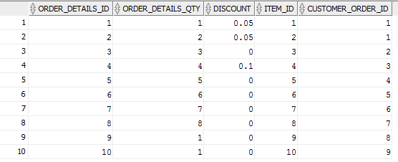

SELECT /*fixed*/ * FROM Item;

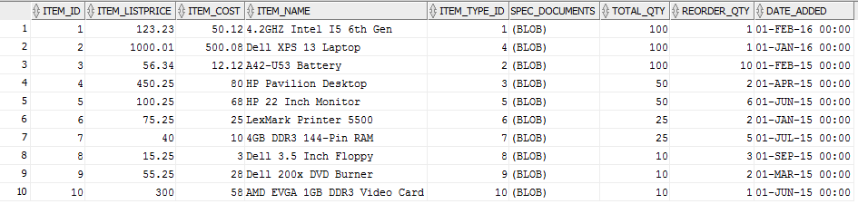

SELECT /*fixed*/ * FROM ItemType;

